Group Report Team 08

# Introduction (Marc)

This report shows how we in the role of the Business Analyst performed a real Use Case under the prerequisite of the agile project methodology. As teaching aids and knowledge support, we have mainly used the BABOK Guide in combination with regular exchanges of supervisors. Since this report focuses on the approach rather than the product, it has been divided into five Knowledge Areas, which can also be found in the BABOK Guide. Knowledge areas are a set of coherent and logically related (but not sequentially) related tasks. These tasks describe activities that helps to achieve the objective of a related knowledge area. The five of the six knowledge areas on which this report is based are exposed: Elicitation and Collaboration, Requirements Lifecycle Management, Strategy Analysis, Requirements Analysis and Design Definition and Solution Evaluation (International Institute of Business Analysis, 2015).

**Summary of the use case**

When selecting the case, we have taken up a topic from the FHNW. This case is under the care of Knut Hinkelmann, who appears in our case as head of the study program Business Information Systems (BIS) and sponsor. The problem addresses the shortage of IT specialists in Switzerland. ICT-Berufsbildung Schweiz announced the results of the ICT Expert Study on 13 September 2018. The study forecasts an additional need for 40,000 skilled workers in 2026. Despite efforts in education and training, this demand cannot be met (Camenzind, 2019). Other demand forecasts show that there are still more training places available, and that in 2024 there will be a shortage of 25,000 ICT specialists (Computerworld.ch, 2012). The BSc Business Information Technology and MSc Business Information System programs focus on educating people who have the skills to understand the business and technical side of the business. The development further into the technical or business direction is not excluded. In general, it was found that a deeper technical knowledge enhances the profile. Especially in programming it can be observed that students have problems with understanding, which makes them doubt today's way of teaching programming. In most cases such modules have a deterrent effect on the students, which leads to a loss of interest in technical computer science. In this case we want to address this issue and find out how to promote this interest, which ultimately meets the economy and the demand for specialists.

**Approach**

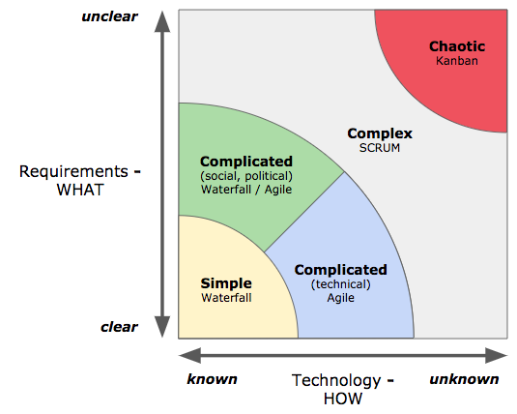To determine the approach or methodology of our project, the Stacey Matrix by Ralph Douglas Stacey was used. Based on the requirements "What" from clear to unclear and the technology "HOW" from known to unknown the project can be classified. In our case knowledge the requirements are not clear and also the approach or the way how to solve the problem is completely unclear. Therefore our project can be classified in the Stacey Matrix see illustration in "Complex". There is a fixed timeline for the project from September 30 to December 21. During this time, the requirements are collected and solution approaches are worked out, which are continuously expanded and improved in consultation with the stakeholders with the aim of achieving a minimally valuable product as the result after each sprint. The current tasks are documented in a Trello board and constantly updated by the Business Analysts.

# Elicitation and Collaboration (Ragesh)

As described in Babok Guide Version 3, as first step we conducted the tasks mentioned as part of the Elicitation and Collaboration Knowledge Area. The objective in this stage was to gain information about the as-Is situation. For this purpose, we first arranged a short meeting with project sponsor, Professor Dr. Knut Hinkelman. The goal of this meeting was to understand and discuss the current (as-is) and potential future (to-be) state. Another objective was to obtain information about potential other stakeholders. Those stakeholders were required to gain information, build requirements out of their inputs and finally to confirm those requirements.

Not every task of Elicitation and Collaboration Knowledge Area was considered in our approach. The following section provides an overview about the tasks and goals, the team conducted in this stage.

**Prepare for Elicitation:**

As a first step, the team discussed the potential stakeholders in a brainstorming session. The stakeholders were discussed based on their knowledge areas – modules taught - and importance to understand the as-is situation. The latter was especially important in defining the stakeholder representing the student’s points of view. Then in a second step the main stakeholders were identified and confirmed within the team. In this stage not relevant stakeholders were eliminated as otherwise too many stakeholders could make the elicitation phase more difficult.

Finally, the determined stakeholders were grouped into two stakeholder group (Students and Lecturers).

After that, based on the stakeholder group corresponding questionnaire were created with stakeholder specific questions. Importance was given on the pre-information to ensure that stakeholders understand the goal of this project. The questionnaire was created in Google Forms and sent out via E-Mail to the stakeholder groups. The stakeholders obtained one-week time to complete the questionnaire.

**Conduct Elicitation:**

Once the deadline for the questionnaire has reached. The gained information (key phrases) from the questionnaire were transferred into an excel spreadsheet.

As a second step the team started to evaluate the key words to prioritize the stakeholder needs and identify potential solutions that may meet those needs.

**Confirm Elicitation Results:**

As a next step, we organized a call with Dr. Andreas Martin (Professor at FHNW) to confirm our elicitation results. We guided the call by informing him about the outcome from the questionnaire and requested him to share his opinion to our results.

We also arranged a focus group with four BSc BIS students to confirm our elicitation results. This was done by creating charts based on their feedback introducing those illustration as part of this focus group meeting. We then further discussed their view on our results.

In both settings the main purpose was to catch any missing information and to close those gaps.

**Which stakeholders were involved and why?**

**Domain Subject Matter Expert :**

* Dr. Prof. Knut Hinkelman and Dr. Prof. Holger Wache having the expertise in the situation of our business objectives and giving us guidance about which other sources should be conducted to get information.

**End User:**

* Lecturers teaching BSc BIS sharing their view on the current situation and providing us with potential future needs to be considered in the business objectives.

**Customers:**

* Graduated BSc BIS Students sharing their experience from the studies and how they could connect their knowledge in their working environment.
* Current BSc BIS Students sharing their feelings and experience during their studies.

**How did you obtain information from stakeholders?**

**Document Analysis:**

Documents regarding the BSc BIS studies at FHNW and a MSc Thesis written by Tatevik Brändlin were analyzed to understand the current situation and already performed surveys and observation regarding this topic.

**Interviews:**

Interviews were conducted with current BSc BIS Students and Dr. Martin Andreas (Lecturer at FHNW) to gain more knowledge about their point of view on the current study programme at FHNW.

**Questionnaire:**

Two different questionnaires (targeting the stakeholder group – students and lecturer) were created and shared via e-mail to gather feedback from stakeholders about their satisfaction and point of view on the current study programme at FHNW.

**How did you communicate with stakeholders?**

Communication with the stakeholder were conducted face-to-face (interviews with Students and Domain Subject Matter Experts) over Skype and with the questionnaire.

**Which techniques were applied and what are the experiences?**

During the collaboration and elicitation phase different kind of techniques were conducted to address the stakeholder groups. Primary selection criteria for the techniques was how the stakeholder group can be attained most effectively to get the most powerful inputs out of them.

As a first step within the project team a brainstorming session was conducted to get a big picture about the understanding of the group members on the business objectives. Based on the first output clustering and topic elimination were conducted to keep the scope lean and achievable during the given timeframe.

Furthermore, the team did document analysis regarding the current situation to gain information around analyses and observations already performed on this topic.

From the document analysis the current study program was understood. Afterwards, the team performed a functional decomposition to break down the insights and to understand what topics are taught at which stage.

Finally to understand the as-is situation interviews were performed and a questionnaire were created and shared with student and lecturers to gain knowledge about the current situation and the point of view by the corresponding stakeholder group.

# Requirements Lifecycle Management (Lawrence)

# Strategy Analysis (Haris)

# Requirements Analysis and Design Definition (Haris)

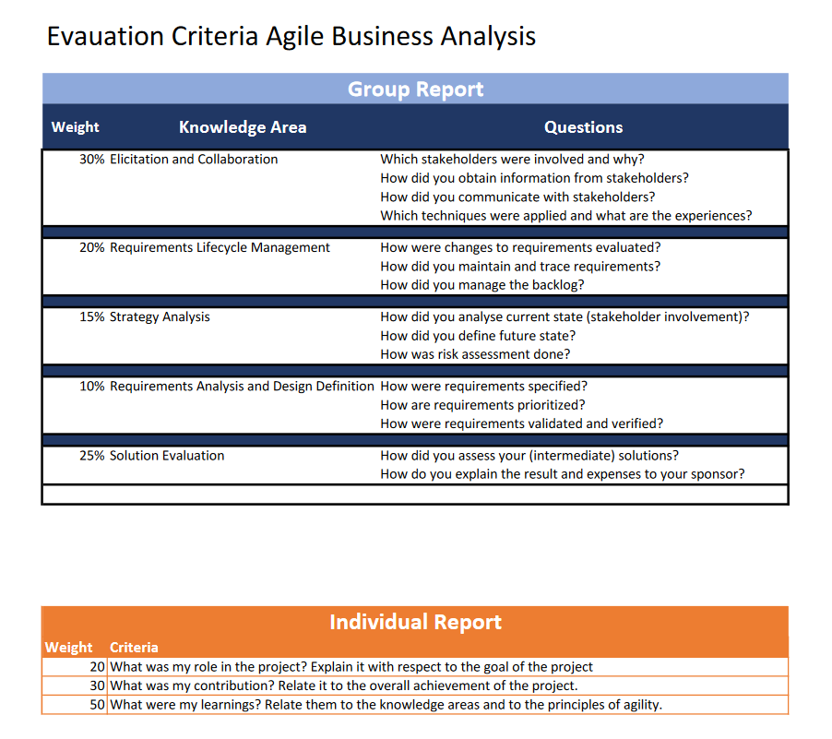

# Solution Evaluation (Marc)

As mentioned in the introduction, we used the Scrum methodology for this project. In our project, we took the current solution in each sprint and continuously gathered feedback from the stakeholders. These feedback loops have motivated us to constantly consider our problem and to work out the solution iteratively.

Our end product is composed of the requirements resulting from the stakeholder groups to create a possible draft that shows an approach to make technical informatics more interesting and understandable. All our techniques described in the elicitation section rely on intensive communication with the stakeholders. In each sprint the requirements were revised until they were finally worked out in a final document together with a draft approach.

Sprint 1:

Sprint 2:

Sprint 3:

Acceptance Criteria

Waren basierend auf den Approach erleichtert es die Zusammenhänge zu verstehen

Throughout an agile project, the stakeholders and agile team continually assess

and evaluate the development solution as it is incrementally built and refined.

Evaluation of the evolving solution with the stakeholders occurs at the end of

every development cycle to ensure the deliverable meets their needs and satisfies

their expectations. The business analyst ensures that the product meets

expectations before a product is released, and identifies new opportunities that

will add value to the business.

What did we do here? We had interviews with stakeholders Students in the 2nd semester BIT. We had interviews with the 3rd Semster Students BIS. We had interviews with Stakeholder Knut Hinkelmann and updates with the Holger. We assessed by presenting and interviewing Andreas Martin. We conducted survery with both stakeholder groups. We created a prototype with raspberry pi etc. We created a first draft as a curriculum. We had always feedback loops that helped us creating new ways to design our solution

Sponsor

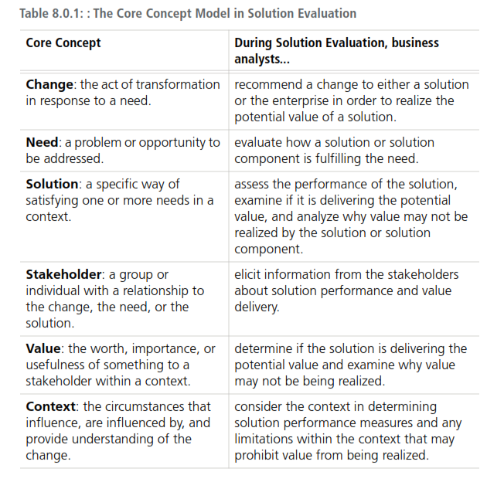

1. **.6 Solution Evaluation**
2. Solution evaluation focuses on solution components and the value they provide.
3. Within an IT context, this includes a focus on the interactions between multiple

systems within the change and the surrounding environment. It is important for a

business analyst working in the IT discipline to understand the context of the

solution and how changes within one system or process can impact other systems

within the environment. These impacts can add negative or positive value to the

other systems, therefore impacting the overall realization of value for the change.

407

Complimentary IIBA

One aspect of solution evaluation within an IT context is software testing or

solution testing. Testing or quality assurance ensures that the solution performs as

anticipated or designed, and that it meets the needs of the business or

stakeholders who requested the change effort. The business analyst works with

quality assurance (testers) to ensure that technical solutions will meet the

business needs as defined by the requirements and other business analysis

deliverables. Testers utilize testing methodologies to plan, develop, and execute

tests. This aspect of solution testing generally focuses on complete process

testing, including across systems to ensure end-to-end solution quality and

accuracy. Business analysts work with stakeholders to plan, develop, and execute

user acceptance tests to ensure that the solution meets their needs.

®

Business analysts make themselves aware of the rationale for implementing an IT

solution and how that rationale works to create solution value. This value

realization is commonly associated with better support for business processes and

procedures.

Member Copy. Not for Distribution or Resale.

Business and technical objectives are associated with benefits and value

realization which are measured against defined metrics used to evaluate success.

Requirements should trace back to the objectives, and this traceability provides a

foundation for solution evaluation. The analysis of solution performance focuses

on technical systems and how they provide potential and actual value to

stakeholders.

Where a large organizational change contains an IT element, an IT solution

evaluation can contribute to a broader benefits realization activity associated with

the whole change program.

As part of solution evaluation activities, a business analyst may work with a team

to complete tasks, such as assessing solution limitations and assessing the

impacts of such limitations. The business analyst may support and assess technical

testing efforts for all, or a portion of, the developed solution.

**BABOK**

**®**

**Guide Techniques**

• Acceptance and Evaluation Criteria

(p. 217)

• Decision Analysis (p. 261)

• Estimation (p. 271)

• Item Tracking (p. 294)

• Metrics and Key Performance

Indicators (KPIs) (p. 297)

• Organizational Modelling (p. 308)

• Risk Analysis and Management

(p. 329)

• Process Modelling (p. 318)

• SWOT Analysis (p. 353)

1. • Vendor Assessment (p. 361)

**.6 Solution Evaluation**

**BABOK**

**®**

**Guide Techniques**

• Acceptance and Evaluation Criteria

(p. 217)

• Business Capability Analysis (p. 230)

• Metrics and Key Performance

Indicators (KPIs) (p. 297)

• Non-Functional Requirements

Analysis (p. 302)

• Process Analysis (p. 314)

**Agile Extension Techniques**

• Personas

• Value Stream Analysis

• Prototyping (p. 323)

• Reviews (p. 326)

• Stakeholder List, Map, or Personas

(p. 344)

• Use Cases and Scenarios (p. 356)

• User Stories (p. 359)

• Workshops (p. 363)